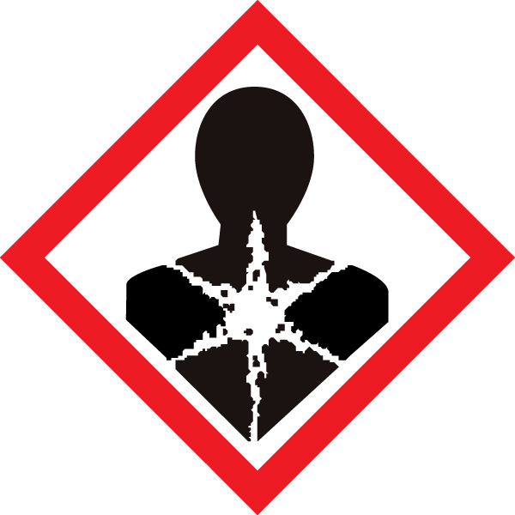

Carcinogens Cliffs Notes

Classifications of Carcinogens:
International Agency for Research on Cancer (IARC)
- Group 1: Definitely Carcinogenic
- Group 2A: Probably Carcinogenic
- Group 2B: Possibly Carcinogenic
- Group 3: Not Classifiable (Usually lack of data)
- Group 4: Not Carcinogenic
Globally Harmonized System:
- Category 1A: Known carcinogen based on human evidence
- Category 1B: Known carcinogen based on animal evidence
- Category 2: Suspected human carcinogen
Category 1 is labeled as H350 and category 2 is labeled as H351 in the GHS system.

A long list of chemicals known to cause cancer can be found at: http://www.oehha.ca.gov/prop65/prop65_list/files/filesp65single110112.pdf

Band Specific Practices: All carcinogens must be used in designated area. Since DCM is a carcinogen that falls into this band, just have the whole lab be the designated area

Use of carcinogenic compounds:
- Review SDS/MSDS (easily found on chemical supplier website)
- Always use them in the hood
- Use smallest quantity possible or a different process if available (i.e. swern/copper oxidation instead of PCC)
- Talk to PI if large scale or you have any questions about handling it

PPE:
- Nitrile gloves (double or thicker gloves if particularly nasty)
- Lab coat, long pants, closed toe shoes
- Safety glasses or splash goggles

