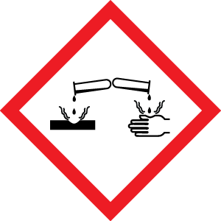
Corrosives Cliffs Notes

Classifications of Explosives:
- Highly Hazardous: Causes visible damage to skin or eyes. pH extreme of < 2 or > 11.5
- Generally Hazardous: Causes irritation to skin or eyes
- Divisions explained here: http://environmentalchemistry.com/yogi/hazmat/placards/class1.html

GHS Hazard codes: H314-H316, H318-H320, H290

Band Specific Practices: Always work in a fume hood with strong corrosives

Use of Corrosives:
- Review SDS/MSDS (easily found on chemical supplier website)
- Always use them in the hood
- Use smallest quantity possible and watch out for fumes
- Talk to PI if large scale or you have any questions about handling it

PPE:
- Nitrile gloves
- Lab coat (with cuffs to protect arms), long pants, closed toe shoes
- Safety glasses or splash goggles/face shield (especially if large quantities are being used).

Specific Handling instructions
- Secondary containment must be used in the cabinets
- Segregate acids and bases
- Keep away from water, metals, flammables, organic halogens, and sources of ignition

