EVANS GROUP RESEARCH PROJECT DESCRIPTIONS

The Evans group is interested in exploring how the unique properties of the lanthanide and actinide metals can be used to advance chemistry in a variety of areas. Described below are several of the research areas of current interest in the group.

One general area of interest involves redox chemistry, one of the most basic types of chemical transformations. One would expect that this would be a mature field. However, we describe below several projects leading to new ways of doing reductive chemistry. These include reductive chemistry governed by steric factors rather than the usual electronic effects, reduction with metals in low oxidation states that were thought for decades to be too unstable to exist. This reductive chemistry is utilized in several ways: new methods for reducing dinitrogen, new reductive methods for initiating polymerizations, and new types of reagents for organic synthesis.

Another general area of activity involves molecules with unusual structure and bonding. This includes unexpectedly bent metallocenes, unusually stable nonclassical carbonium ion complexes, and a set of complexes in which all of the metal ligand bonds are much longer than normal, the so-called long bond organometallics.

In these projects, the Evans Group examines fundamental aspects of the chemistry as well as specific applications.

Listed below are the titles of the topics so you can see what follows. This document does not include all of our research interests and activities, nor does it contain some of the latest surprising results that are as yet unpublished.

The headings of the sections that follow are:

Long Bond Organometallics, New Types of Organometallic Complexes

Sterically Induced Reduction, A New Method of Reduction

New Oxidation States in the Periodic Table

New Reagents for Organic Synthesis

New Approaches to Dinitrogen Chemistry

Lanthanide-Based Diene Polymerization Chemistry, New Routes to Synthetic Rubber

Long Bond Organometallics, New Types of Organometallic Complexes

For many years the "rules" for stable bond distances in organometallic complexes of the electropositive lanthanide, actinide, alkali, and alkaline earth metals have been well established. In these heavily ionic systems, ionic radii could be reliably used to estimate metal ligand bond distances expected to be stable.

However, the discovery of the sterically crowded tris(pentamethylcyclopentadi-enyl) complexes, (C5Me5)3M, has changed this. This is a class of complexes that for decades was assumed to be too sterically crowded to exist. In these complexes, each of the 15 metal-carbon bonds is longer than expected. Some distances are over 0.15 Å longer than typical.
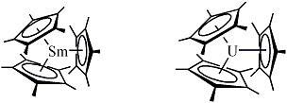
These unusual "long bond organometallics" also have unusual chemistry. As described in another section, they are one-electron reductants even if the metal is redox inactive, a phenomenon called
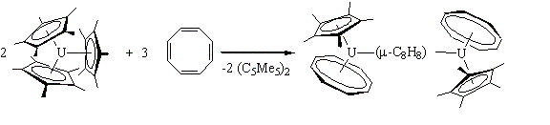
sterically induced reduction (SIR). The (C5Me5)3M complexes also display alkyl reactivity—they polymerize ethylene, ring open ethers, and do insertion chemistry with CO and CO2.
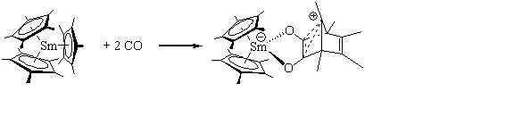
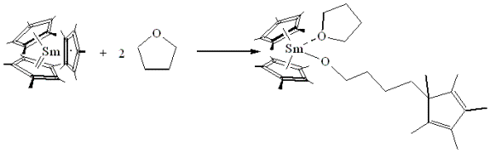
Our group is working to fully define the chemistry of these long bond organometallics. One new and unexpected reaction of these complexes is the formation of even more crowded base adducts, (C5Me5)3ML. Equally surprising, these complexes can be isolated with L ligands that are not traditional for the f elements, e.g. CO and end on bound N2 as described in the following two papers:
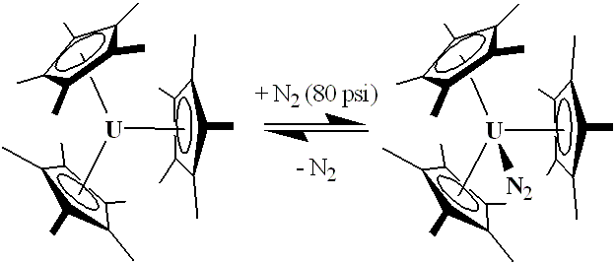
"A Monometallic f Element Complex of Dinitrogen: (C5Me5)3U(η1-N2)" Journal of the American Chemical Society 2003, in press.

"Comparative Reactivity of Sterically Crowded nf3 (C5Me5)3Nd and (C5Me5)3U Complexes with CO: Formation of a Non-Classical Carbonium Ion vs. an f Element Metal Carbonyl Complex" Journal of the American Chemical Society, 2003, in press.

Our group also seeks to determine the broader implications of an entire class of complexes in which all the metal ligand bonds are longer than normal. What other classes of long bond complexes are just waiting to be discovered? The (C5Me5)3M complexes were obtained by developing syntheses in which the sterically crowded (C5Me5)3M option was the only viable choice. Similar synthetic strategies should lead to other classes of sterically crowded species.
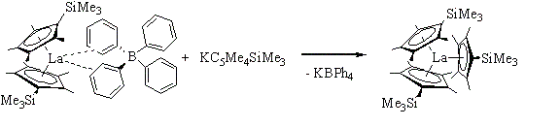
Leading References:

"The Chemistry of Tris(pentamethylcyclopentadienyl) f Element Complexes, (C5Me5)3M" Chemical Reviews 2002, 102, 2119-2136.

"Multiple Syntheses of (C5Me5)3U" Organometallics 2002, 21, 1050-1055.

"How Much Steric Crowding is Possible in Tris(eta5-pentamethylcyclopentadienyl) Complexes? Synthesis and Structure of (C5Me5)3UCl and (C5Me5)3UF" Journal of the American Chemical Society 2000, 122, 12019-12020.

“The Reaction Chemistry of Sterically Crowded Tris(pentamethylcyclopentadienyl)-samarium” Journal of the American Chemical Society 1998, 120, 9273-9282.

“Reactions of Olefin Polymerization Activators with Complexed Pentamethylcyclopentadienyl Ligands: Abstraction of Tetramethylfulvalene” Journal of the American Chemical Society 1998, 120, 2180-2181.

“Polymerization Reactivity of (C5Me5)3Sm and the Synthesis of the First Tris(pentamethylcyclopentadienyl) Actinide Complex, (C5Me5)3U” Angewandte Chemie International Edition in English 1997, 36, 774-776.

Sterically Induced Reduction, A New Method of Reduction

Redox reactions constitute one of the major classes of chemical transformations. Since they have been studied for years, it would be surprising to find a new way to do such reactions.

However, the discovery of the sterically crowded tris(pentamethylcyclopentadienyl) complexes, (C5Me5)3M, a class of complexes that for decades was assumed to be too crowded to exist, has opened up this possibilty. These (C5Me5)3M complexes participate in one electron reduction chemistry even when the metal is redox inactive. This reactivity suggests a new type of reduction reaction is available.
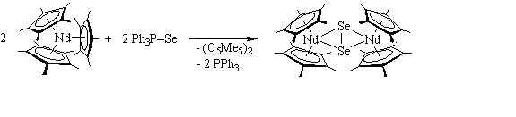
The (C5Me5)3M reduction reactions occur via a (C5Me5)-/(C5Me5). redox couple,
(C5Me5)3M à e- + 0.5 (C5Me5)2 + [(C5Me5)2M]+

but this type of C5Me5 reactivity only occurs when the ligands are in a sterically crowded environment. Hence, this new type of reduction has been called sterically induced reduction (SIR).

Since it is usually electronic factors, not steric factors, which affect redox chemistry, this phenomenon is particularly unusual. Our group is intent in identifying all the ramifications of this type of reactivity. These efforts involve mechanistic studies of the known (C5Me5)3M reductions, synthesis of new types of complexes that could do this chemistry, and an examination of the chemical transformations possible via this new reductive route.
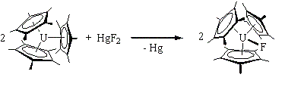
Leading References:

"The Chemistry of Tris(pentamethylcyclopentadienyl) f Element Complexes, (C5Me5)3M" Chemical Reviews 2002, 102, 2119-2136.

"Recent Advances in f Element Reduction Chemistry" Journal of Organometallic Chemistry, 2002, 652, 61-68.

"The Expansion of Divalent Organolanthanide Reduction Chemistry Via New Molecular Divalent Complexes and Sterically Induced Reduction Reactivity of Trivalent Complexes" Journal of Organometallic Chemistry 2002, 647, 2-11.

"Formal Three Electron Reduction by an f element Complex: Formation of [(C5Me5)(C8H8)U]2(C8H8) from Cycloctatetraene and (C5Me5)3U" Angewandte Chemie, International Edition in English 2000, 39, 240-242.

"The Trivalent Neodymium Complex, (C5Me5)3Nd, is a One Electron Reductant!" Angewandte Chemie, International Edition in English 1999, 38, 1801-1803.

New Oxidation States in the Periodic Table

So much effort has been given to identifying the extremes of oxidation states in the periodic table, that it seems unlikely that one could find new oxidation states.

However, recently the Evans Group in collaboration with that of Dr. Mikhail Bochkarev in Nizhny Novgorod, Russia, discovered the first molecular complex of Tm2+. Our group subsequently obtained the first molecular Dy2+ complex, and the Bochkarev group identified the first molecular Nd2+ complex. The three new compounds are shown below:
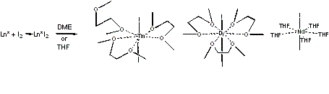
The three divalent ions have estimated reduction potentials of -2.3 V, -2.5 V, and -2.6 V, respectively, compared to Sm2+ at -1.5 V (vs NHE). Since Sm2+ has provided a wealth of new chemistry (see the decamethylsamarocene website), these new ions promise even more.

The Evans Group is studying all aspects of the chemistry of these ions, i.e. their utility in inorganic, organometallic, and polymer chemistry, as well as in organic synthesis. For example, the isolation of the iodides above have led to new metallocenes, new dinitrogen reduction products, and new ways of polymerizing isoprene. Several of these topics are discussed in more detail in following sections.

Leading References:

"The Expansion of Divalent Organolanthanide Reduction Chemistry Via New Molecular Divalent Complexes and Sterically Induced Reduction Reactivity of Trivalent Complexes" Journal of Organometallic Chemistry 2002, 647, 2-11.

"Synthesis and Structure of the First Molecular Thulium(II) Complex, TmI2(MeOCH2CH2OMe)3" Angewandte Chemie, International Edition in English 1997, 36, 133-135.

"The Availability of Dysprosium Diiodide as a Powerful Reducing Agent in Organic Synthesis: Reactivity Studies and Structural Analysis of DyI2(DME)3 and Its Naphthalene Reduction Product, J. Am. Chem. Soc. 2000, 122,11749-11750.

"Utility of Neodymium Diiodide as a Reductant in Ketone Coupling Reactions" Org. Lett. 2003, 5, 2041-2042.

"Dinitrogen Reduction by Tm(II), Dy(II), and Nd(II) with Simple Amide and Aryloxide Ligands" Journal of the American Chemical

Society, 2003, 125, 10-11.

New Reagents for Organic Synthesis

For many years there were no reagents which could accomplish reductive transformations in organic synthesis in the reduction potential range between that of SmI2/HMPA (-1.5 V vs NHE) and alkali and alkaline earth metals (-2.7 V vs NHE). That meant that substrates that could not be reduced by SmI2/HMPA had to be reduced with reductants that were too powerful to be selective. Often these reactions required alkali metal/liquid ammonia conditions that inherently contained a proton donor (NH3).

The discovery of the first molecular complexes of Tm2+, Dy2+, and Nd2+, the ether soluble diiodides, TmI2(DME)3, DyI2(DME)3, and NdI2(THF)5, provides the opportunity to fill in this long-standing gap in organic reduction chemistry between SmI2/HMPA and alkali and alkaline earth metal reductions.
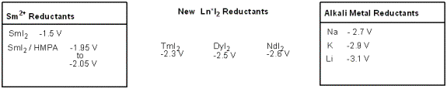
Three preliminary papers from our group (see below) have shown that these "Ln*I2" reagents (Ln* = Tm, Dy, Nd) can accomplish synthetic organic transformations like the commonly used organic reagent SmI2/HMPA but without the carcinogenic hexamethylphosphoramide (HMPA). In addition, these much more strongly reducing ions offer new possibilities for selective organic reductions.

This chemistry of the Ln*I2 reagents is at the stage SmI2 was in the 1980's. At that time there were only a few papers on SmI2. Now some 60-100 papers per year cite SmI2 as a reagents.

The new Ln*I2 reagents are shown below. The three divalent ions have estimated reduction potentials of -2.3 V, -2.5 V, and -2.6 V, respectively, compared to Sm2+ at -1.5 V (vs NHE).
Some typical transformations are shown:
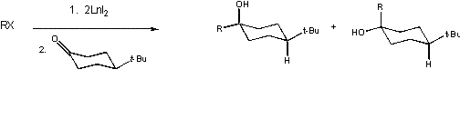
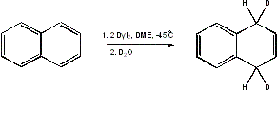
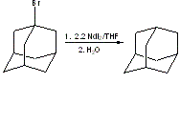
Leading References:

"Ketone Coupling with Alkyl Iodides, Bromides, and Chlorides using Thulium Diiodide: A More Powerful Version of SmI2(THF)x/HMPA" Journal of the American Chemical Society 2000, 122, 2118-2119.

"The Availability of Dysprosium Diiodide as a Powerful Reducing Agent in Organic Synthesis: Reactivity Studies and Structural Analysis of DyI2(DME)3 and Its Naphthalene Reduction Product" Journal of the American Chemical Society 2000, 122,11749-11750.

"Utility of Neodymium Diiodide as a Reductant in Ketone Coupling Reactions" Organic Letters 2003, 5, 2041-2042,

New Approaches to Dinitrogen Chemistry

Investigations of the reaction chemistry of the unusual bent metallocene, (C5Me5)2Sm, led to the first example of a bimetallic dinitrogen complex in which the metals and the N2 unit were all planar in the M2(m-h2,h2-N2) unit.
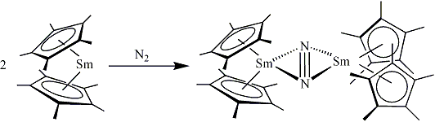
This is an unusual bonding arrangement since both metals are interacting with the same pi orbital of dinitrogen!

For many years, this highly reactive complex was mostly a novelty. A few other examples of this geometry were found, but no extensive chemistry of this M2(mu-eta2,eta2-N2) unit was developed. The recent discovery of the first molecular complexes of Tm(II), Dy(II), and Nd(II), have provided new opportunities to study dinitrogen reduction. One of the reasons that these new divalent oxidation states were not discovered earlier is that they reduce dinitrogen!
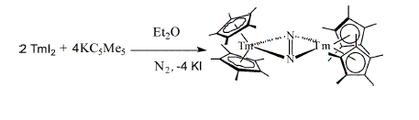
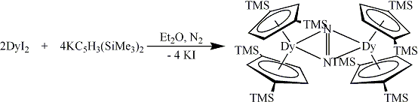
We have found that with a variety of ligands these Ln*(II) ions (Ln* = Tm, Dy, Nd) reduce dinitrogen to the formerly rare planar M2(m-h2,h2-N2) moiety. In the past year alone over 10 new examples of this type of complex have been identified. These complexes provide opportunities to study the chemistry of reduced dinitrogen in new metal ligand environments.

Although the synthesis phase of this project is still in progress, it is now time to fully study the reactivity of these new dinitrogen complexes.

Leading References:

"Dinitrogen Reduction by Tm(II), Dy(II), and Nd(II) with Simple Amide and Aryloxide Ligands" Journal of the American Chemical Society, 2003, 125, 10-11.

"Facile Dinitrogen Reduction Via Organometallic Tm(II) Chemistry" Journal of the American Chemical Society 2001, 123, 7927-7928.

Lanthanide-Based Diene Polymerization Chemistry,

New Routes to Synthetic Rubber

Neodymium-based catalysts are among the best diene polymerization systems known for formation of high-cis polydienes. Nd compounds can provide >98% cis-1,4,-polybutadiene and >98% cis-1,4-polyisoprene, from butadiene and isoprene, respectively. This polymerization system has potential impact on energy related issues, since natural rubber is primarily cis-1,4-polyisoprene and the polydienes are crucial components in automobile, truck, and airplane tires. Tire performance in turn is critical to gasoline mileage.
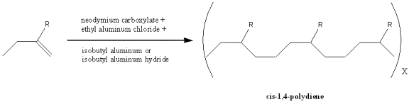
The development of synthetic polyisoprene chemistry is important since there is only a limited supply of natural rubber in the world. Natural rubber is now found only in Southeast Asia due to the blights that destroyed the rubber trees and hence the rubber industry elsewhere. For this reason, synthetic rubber can be considered a strategic commodity.

We are studying lanthanide-based diene polymerization not only because it is important to synthetic rubber, but also because it is one of the best catalytic lanthanide systems known. This successful system undoubtedly contains information on how the unique properties of the lanthanides can be applied in organometallic and catalytic chemistry to give superior performance. If we can understand the basis for this high activity and high cis selectivity, we may learn how to better utilize the lanthanides in catalysis more generally.

Although neodymium catalysts provide high-cis-1,4-polydienes, relatively little is known about the mechanism of catalysis or even the composition of the catalyst precursors. The catalysts in the literature typically are complicated three part systems. Neodymium salts, generally carboxylates derived from industrially available carboxylic acids (mixtures of isomers of versatic acid, octanoic acid, or naphthenoic acid), are the starting materials. These ill-defined carboxylates are then treated with an ethylaluminum chloride compound, e.g. EtAlCl2 or Et2AlCl, to form an intermediate which is subsequently treated with a large excess of an isobutylaluminum-containing compound, e.g. AliBu3 or iBu2AlH, to generate the active catalysts. In addition, various schemes have been reported for "aging" the catalyst and for varying the order of addition of the reagents in efforts to increase activity.

This project involves mechanistic studies of the isoprene polymerization, synthetic studies of model complex systems, and development of new polymerization protocols that are simpler and less prone to variation than those currently in the literature.

Leading References:

"Polymerization of Isoprene by a Single Component Lanthanide Catalyst Precursor" Macromolecules, 2003, 36, 4256-4257.

"Lanthanide Carboxylate Precursors for Diene Polymerization Catalysis: Syntheses, Structures, and Reactivity with Et2AlCl" Organometallics 2001, 20, 5751-5758.

"Reactivity of the Substituted Butadienes, Isoprene and Myrcene, with Decamethylsamarocene" Organometallics 2001, 20, 5648-5652.

If you have read this far, congratulations!!! What follows is a series of more specific descriptions of other research areas of interest in the Group. The headings include:

Polyolefins

Biodegradable Polymers

Carbocation Chemistry

Unsaturated Hydrocarbon Transformations

Small Molecule Activation

Cyclooctatetraenyl Chemistry

Luminescent Materials

Main Group Chemistry

Zirconia Chemistry

Three Way Auto Catalysts

Metalloalkoxide Chemistry

Actinide Chemistry

Mass Spectrometric Studies

Listed below are brief descriptions of some of the other research projects in the Evans Research Group. More information can be obtained from the publications from the Evans Group which are listed at the end of each project. The full titles of the papers can be accessed in the Evans Group Publication List.

Polyolefins. The Evans Group is examining the utility of lanthanide metal catalysts in the synthesis of unusual hydrocarbon polymers. Since the lanthanide metals have not been heavily investigated in the past, they offer new options for polymer synthesis. Organolanthanide complexes have the added advantage that they can initiate polymerization without an aluminum co-catalyst such as MAO. Efforts to define the basic mechanisms of lanthanide-based olefin polymerization with highly active species such as [(C5Me5)2SmH]2 (reference in Evans Group Publication List #44-JACS 1983, 105, 1401) and the unexpectedly bent (C5Me5)2Sm (reference #51-JACS 1984, 106, 4270) led to the use of field desorption mass spectrometry (FDMS) for analysis. Surprisingly this technique provides considerable mechanistic information about the formation of the solid polymers. For example, the FDMS data shown below on an organosamarium-generated system indicates that three types of polyethylene polymers are in the sample including polyethylene chains tagged with just one and just two styrene monomers per chain.
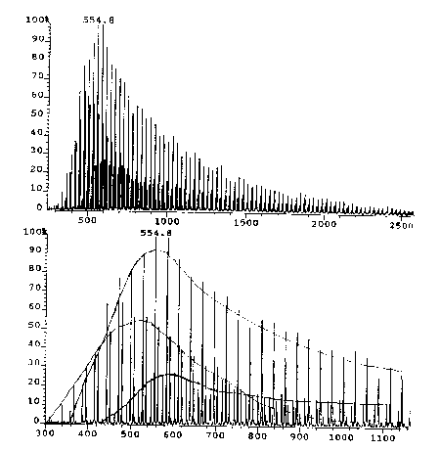
Several projects exist in the group to develop efficient and stereospecific oligomerization, polymerization, and co-polymerization of alpha olefins. In addition, the lanthanide-based catalysts which are the optimum for the formation of certain types of cis-polybutadiene are being studied (ref. in Evans Group pub list: #191-Angew. Chem. Eng. 1997, 36, 774; #187-J. Am. Soc. Mass Spect. 1996, 7, 1070; #186-Organometallics 1996, 15, 3210; #177-Macromolecules 1995, 28, 7929).

Biodegradable Polymers. Ring Opening Polymerization. Lanthanides are also superior for ring opening polymerization of caprolactone and lactide (shown below) which polymerize to biodegradable polymers which are attractive for environmental reasons. There are projects in the Group to better understand the basis of this reactivity and to use this knowledge to generate unusual copolymers (ref. in Evans Group pub. list: #162-Polym. Preprints 1994, 35, 534; #157-Macromolecules 1994, 27, 4011; #151-Macromolecules 1994, 27, 2330).
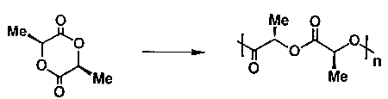
Carbocation Chemistry. The discovery that (C5Me5)3Sm would react with CO to make a thermally stable, alkane soluble carbocation not only got graduate student Kevin Forrestal's picture in Chemical and Engineering News (Jan. 8, 1996, p. 32), but it opened up a new way to study carbocation chemistry. Carbocations are critical intermediates in many types of stoichiometric, catalytic, and polymerization reactions, but they are difficult to study since they are rarely stable at room temperature. The compound shown below provides a new way to study carbonium ion chemistry (ref. in Evans Group pub. list: #179-JACS 1995, 117, 12635).
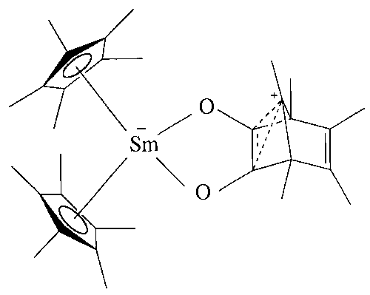
Unsaturated Hydrocarbon Transformations. The metallocenes, (C5Me5)2Sm(THF)2 and (C5Me5)2Sm, are excellent at activating unsaturated hydrocarbons for subsequent derivatization. The Group has projects involving activation of unsaturated substrates and their subsequent transformation chemistry. An unexpectedly planar anthracenide dianion complex is shown below (ref. in Evans Group pub. list: #214-JACS 1998, 120, 11342; #149-JACS 1994, 116, 2600; #142-Organometallics 1993, 12, 2618; #113-JACS 1990, 112, 2314).
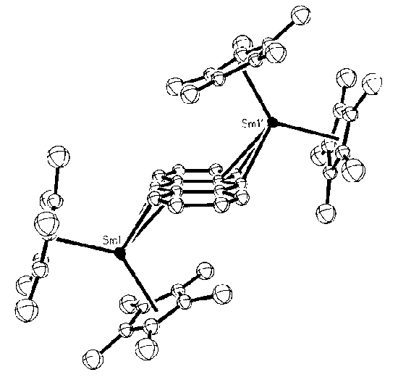
Small Molecule Activation. The oxophilic lanthanides are good at activating oxygen containing substrates like CO, NO, and CO2. The Group has several projects involving the conversion of these low value substrates to more valuable products (ref. in EVANS GROUP pub. list: #203-Organometallics 1998, 17, 2103; #199-Inorg. Chem. 1998, 37, 770; #95-JACS 1988, 110, 4983; #92-JACS 1988, 110, 2772; #69-JACS 1986, 108, 1722).
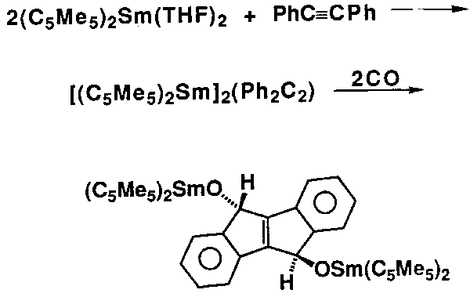
Cyclooctatetraenyl Chemistry. The Evans Group has recently discovered the unusual bimetallic bent triple decker sandwich compounds shown below. The chemistry of these species and the opportunities for new f element chemistry available via the cyclooctatetraenyl ligand are being explored (ref. in Evans Group pub. list: #213-JACS 1998, 120, 9555).
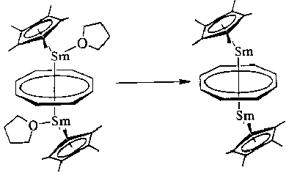
Luminescent Materials. The Evans Group is interested in materials containing europium and terbium since these elements have intense, energy-efficient emission in the red and green regions of the spectrum, respectively, and are used in many practical devices ranging from color TV to energy efficient fluorescent lamps to flat panel displays. Since the strong line-like emission bands of Eu3+ and Tb3+ occur at wavelengths to which the eye is particularly sensitive, small amounts of input energy can be used to generate what the eye sees as bright red and green light. The energy-saving fluorescent lamps which use these elements could be improved by controlling the particle size and the homogeneity of the ions in the transparent matrix which contains the emitters and by understanding how luminosity is related to concentration quenching. The Evans Group is addressing these questions by synthesizing well defined molecular polymetallic and heteropolymetallic Eu and Tb complexes, examining their conversion to luminescent materials using sol gel processes, and studying the luminescence properties of these materials. The intense luminescence of a europium alkoxide obtained in collaboration with Dr. Wytze van der Veer in the UCI Department of Chemistry Laser Laboratory is shown below (ref. in Evans Group pub. list: #210-J. C. S. Chem. Comm. 1998, 2367; #208-Inorg. Chem. 1998, 37, 5251; #193-J. Chem. Soc. Dalton Trans. 1997, 3035).
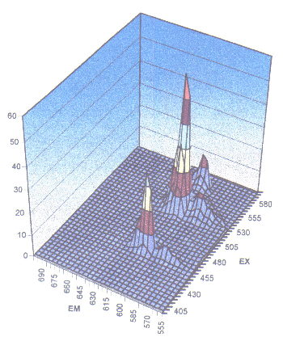
Main Group Chemistry. Zintl ions are poly(main group element) polyanions, (Ex)n-, which are typically made by sodium reduction of the element in liquid ammonia. They are of interest structurally, theoretically and in understanding alloy chemistry. The Group has found that (C5Me5)2Sm provides an alternative effective route to synthesize and stabilize Zintl ions as diverse as (Bi2)2-, (Sb3)3-,and (Se3)4-. This is just one aspect of how the special chemistry available through organolanthanides can be used to advance main group chemistry (ref. in Evans Group pub. list: #185-Inorg. Chem. 1996, 35, 4238; #160-Angew. Chem. Eng. 1994, 33, 2110; 155-Inorg. Chem. 1994, 33, 2719; #131-J. C. S. Chem. Comm. 1992, 1138; #124-JACS 1991, 31, 2492).
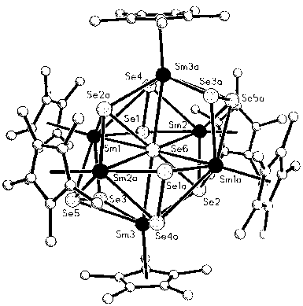
Zirconia Chemistry. Zirconium oxide has some superior properties which make it a desirable component in practical devices ranging from catalytic converters in automobiles to fuel cells. The Group is studying how to make precursors to ZrO2 materials which will deliver superior performance. A polymerizable diolefin zirconium complex is shown below (ref. in Evans Group pub. list: #197-J. Chem. Soc. Dalton Trans. 1997, 4503; #201-Polyhedron 1998, 17, 869; #198-Polyhedron 1998, 17, 299)
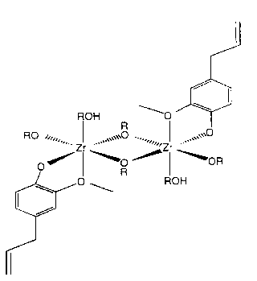
Three Way Auto Catalysts. Cerium Chemistry. Cerium is a critical component in the automobile catalytic converters since the CeO2 / Ce2O3 + O2 equilibrium provides a basis for storing and delivering oxygen to the catalyst when needed. Since higher performance catalysts which operate over a wider temperature range are needed for environmental reasons, there are many opportunities for improvement of these catalysts which typically involve ceria, zirconia, alumina, and precious metals (Ru, Pd, Pt). The Group is pursuing a molecular approach to these improvements (no publications yet!).

Metalloalkoxide Chemistry. Interest in new materials related to the previous two sections and interest in replacements for the ubiquitous cyclopentadienyl ligands have led to the development of metalloalkoxide ligands based on zirconium. The di-zirconium-nona-isopropoxide anion, [Zr2(OiPr)9]-, called dzni for short, has led to several new projects using this inorganic ligand system (ref. in Evans Group pub. list: #197-J. Chem. Soc. Dalton Trans. 1997, 4503).
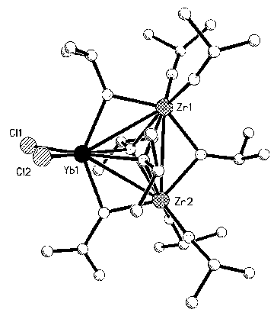Actinide Chemistry. The recent discovery of a synthesis for (C5Me5)3U has opened up some new avenues of research in organoactinide chemistry (ref. in Evans Group pub. list: #191-Angew. Chem. Eng. 1997, 36, 774).
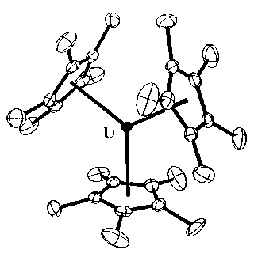
Mass Spectrometric Studies. The Evans Group collaborates closely with Dr. John Greaves, head of the UCI Department of Chemistry Mass Spectroscopy Facility, to use new aspects of mass spectroscopy for the advancement of organometallic chemistry. The use of field desorption mass spectrometry (FDMS) to analyze the mechanisms of polymerization is one example. Projects utilizing electrospray mass spectrometry are also being pursued in the Group (ref. in Evans Group pub. list: #187-J. Am. Soc. Mass Spect. 1996, 7, 1070; #186-Organometallics 1996, 15, 3210; #177-Macromolecules 1995, 28, 7929).

Back to OVERVIEW OF EVANS GROUP RESEARCH

